WHAT REALLY HAPPENED AT MAUNGANUI BLUFF ?

Read, “The Titford Story” by Justitia published in 1989. ISBN 0-473-00937-4

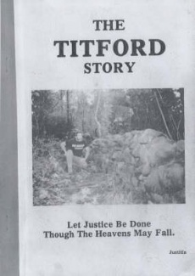
For the true story on what really happened at Maunganui Bluff read, “The Titford Story” by Justitia published in 1989. This book is based on the diaries of Susan Titford written between 1987 and 1990.

It gives a brief history of Te Roroa’s “alleged” claim. It tells how Te Roroa and the Police harassed the two young newly weds, how their houses were burnt to the ground, machinery destroyed, stock shot and squatters refusing to leave their property. It tells how Sue’s mother and father were at the farm during many of the assaults and machinery sabotages etc. It tells how Sue was in fear of her husband being shot or assaulted. It tells how she had three miscarriages through the stress, harassment and fear for her husband’s safety. It has letters Sue wrote the Ministers and the Queen asking for Police protection for her and Allan, but the Police always sided with Te Roroa. It tells how the subdivision that was to completely pay off their loan was sabotaged by Te Roroa’s “alleged” Waitangi Tribunal claim, a claim that had been rejected after a full judicial inquiry by Chief Judge Shepherd in 1939. It shows how dedicated she was to saving the farm with her husband Allan.

It tells a completely different story than what we were led to believe at Allan Titford’s recent trial where the Police and the Crown were determined to silence him for what they did to this young innocent couple 25 years ago by putting Allan behind bars for 24 years. Please read this book if you want to know the true “Titford Story” as told by Susan Titford in her diaries at the time it all happened.

For a copy of “The Titford Story”, check out your library or there are books for sale on the Internet.

